CHRISTMAS BLOG
TOP CREATIVE WAYS TO LIGHT YOUR FRONT DOOR
Lighting designer Sally Stephenson gives us her 5 top tips for lighting entrances.
At this time of year a house should look welcoming and warm, and the place to start is the front door. There’s probably no need to go as far as our friend above has, but with some careful design and planning Owl Lighting can make an entrance look spectacular all year round (and avoid stubbed toes).
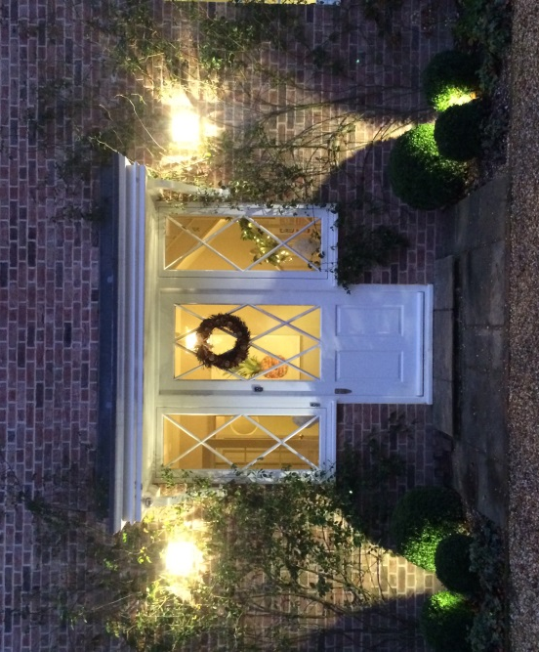

Sally Stephenson, a lighting designer with experience of over 300 residential projects reveals her 5 top tips for lighting houses and gardens:
- Lighting should look as good during the day as at night so choose the perfect light fittings to suit the style of your house – whether classic carriage lanterns or chic & minimal pillar lights.
- Consider lighting the path to your front door to guide guests all the way from gate to door.
- If you’ve got a front garden you can create beautiful effects with spike lights in amongst the planting – hidden light creates a discreet wash of light onto paths.
- You can use motion sensors to operate your decorative lighting – which turns on the lights as guests approach.
- Lighting design can be as simple as tea lights in jam jars or spike lights in flower beds – so be creative and have fun.
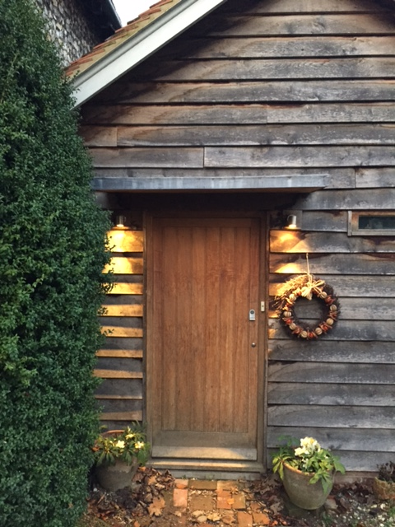

Find us at www.owl-lighting.co.uk and Father Christmas may well shun the chimney this year for the front door instead…
